John Rogers - Picture Day: September 30th
Your school’s background is Summer Clouds
Packages Complementary retouching is included.
B. Classic | $25
2 - 5x7
16 - Wallets
D. Ultimate | $45
A. Basic | $15
2 - 3x5
8 - Wallets
C. Deluxe | $30
- - 8x10
- - 5x7
8 - 3x5
16 - Wallets
Complementary Studio 8x10 Gift Certificate (Reg. $40)
E. Digital Image $35
2 - 8x10
4 - 5x7
8 - 3x5
24 - Wallets
1 - Digital Image
Complementary Studio 8x10 Gift Certificate (Reg. $40)
Add-ons Order additional prints with the purchase of any package
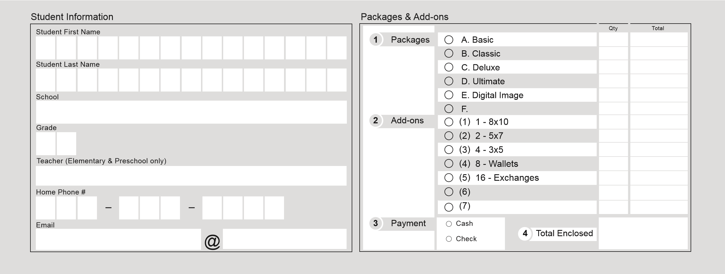
(1) 1 - 8x10 $12 (2) 2 - 5x7 $12 (3) 4 - 3x5 $12 (4) 8 - Wallets $12 (5) 16 - Exchanges $12 QUESTIONS? For information and questions regarding our packages and services please call us at 1-800-347-4687.
SATISFACTION GUARANTEE If not satisfied, return your portraits on RETURNED CHECKS Payment by check is your express authorization that it may retake day and we will re-photograph free of charge. be converted into a one-time Electronic Fund Transfer (EFT) from your account, and all returned checks or EFTs may be re-presented electronically along with a separate REORDERS Order what you need now and avoid the higher reprint EFT or demand draft for the maximum returned check fee allowed by state law. For prices. Reorders may take up to 6-8 weeks for delivery. Inquiries: 800.460.0124 or www.statecheckfees.com

Prepay Online by Credit Card
- Go to www.yuenluistudio.com and click on School Prepay
- Enter Keyword: John Rogers
- Click View Gallery for John Rogers Prepay (for appropriate date).
- Complete the online order process
* It is no longer necessary to provide a receipt to the photographer for online orders.
Check or Cash Payments Fill out ONE form per student. Enclose exact payment of cash or check payable to Yuen Lui Studio in envelope. Please do not combine payments, for siblings, on one check.

